Children and Young Peoples Public Health Service 0-19- Request for Nocturnal Enuresis (Bedwetting) Intervention form and guidance to support your request

This criteria is to guide schools, families, children and young people (CYP) and professionals on when and how to refer a CYP to the Children and Young Peoples Public Health Service 0-19, for Nocturnal Enuresis (bedwetting) Intervention.

Who Can Refer
- School staff (teachers, SENCOs, pastoral teams, safeguarding leads)
- Parents/carers
- Young people (self-referral from age 11+)
- GPs and health professionals
- Social workers / Early Help
- Voluntary sector partners
Consent should be obtained where appropriate.

Universal services

To access support for low level concerns requiring brief advice, early support or signposting, please use resources available from: School nursing :: Dorset HealthCare University NHS Foundation Trust

And signpost Parents/Carers and CYP to:

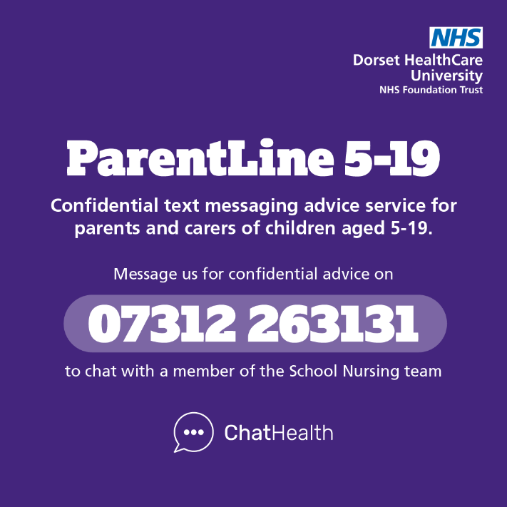
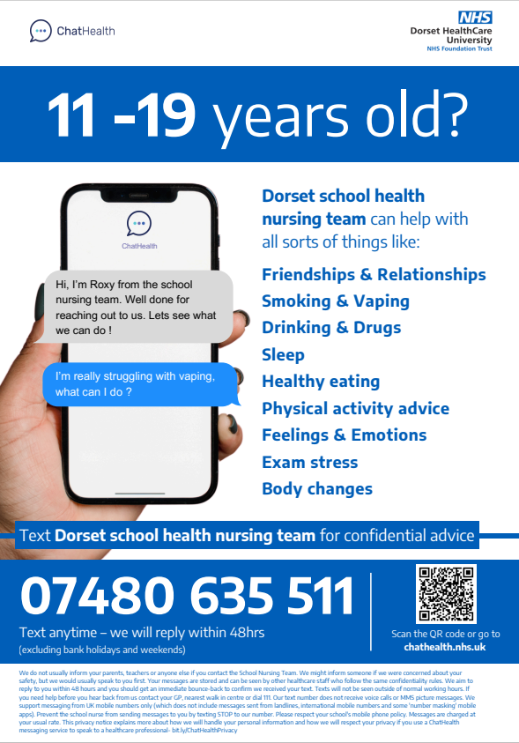
Nocturnal Enuresis Intervention
To request Nocturnal Enuresis Intervention for CYP requiring support for bedwetting please complete the Nocturnal Enuresis referral form below. The service can offer individualised support and issue a bedwetting alarm if assessed as appropriate. Support will consist of assessment, intervention, care planning, liaison with school/family and signposting either via video call (Attend Anywhere), telephone or face to face in school or at a local clinic.
Criteria:
- CYP that are night-time bedwetting (5 nights per week or more).

- CYP aged 7-19 years old.

- CYP who live in Dorset- If they live outside of Dorset please refer to the School
Nursing/ Continence Team in that area for support.
- If the child is experiencing secondary night-time wetting (child has been dry before for a period of 6 months or longer). Please ensure that they have been reviewed by a GP prior to this referral, to rule out any underlying cause.
If the criteria are not met, please consider below options:
- Constipation or soiling- please contact the GP.

- To get support for toileting or daytime wetting, then please complete the School Nursing Request for Support form on our website:
Dorset HealthCare :: Requesting school nursing support

- To get support for night-time wetting for children under 7 years old, please also complete the School Nursing Request for Support form on our website:
Dorset HealthCare :: Requesting school nursing support

- If wetting is occurring 4 nights a week or less, please do not refer for Nocturnal Enuresis Intervention, instead complete the School Nursing Request for Support form on our website:
Dorset HealthCare :: Requesting school nursing support

Urgent or Emergency Situations
The School Nursing Service is not an emergency service.
Immediate risks must be escalated to emergency services, GP, social care, or the school’s safeguarding lead. If it is an emergency, dial 999 or visit A&E. To speak to someone urgently for mental health support, please call Connection 24/7 helpline, on 0800 652 0190 (freephone) or access via NHS 111 for free.

Children and Young Peoples Public Health Service- 7 – 19yrs NOCTURNAL ENURESIS (bedwetting) REFERRAL FORM

The nocturnal enuresis intervention is only for children and young people that are night-time wetting and 7 years old or above.
We do not see children with constipation or soiling- please contact your GP.
If you need support around toileting or daytime wetting, then please complete the School Nursing Request for Support form on our website:
Dorset HealthCare :: Requesting school nursing support
For support for night-time wetting for an under 7 year old, please also complete the School Nursing Request for Support form on our website:
Dorset HealthCare :: Requesting school nursing support

Referrer Details
Name of Referrer: | Designation:
Contact No: | Email:
.
Patient Details
Name: | Date of Birth:
NHS Number: | Age:
Home Address including post code: | Sex:
Home Address including post code: | Ethnicity:
Home Address including post code: | School:  ECHP in Place? Yes/ No
Home Address including post code: | GP:
Home Address including post code: | Social Worker/ Early Help Worker:  Child In Care: Yes/ No
Home Address including post code: | Military family: Yes/ No
Parent/Carer details: | Relationship to child:
Parent/Carer e-mail: | Telephone No:
Any communication difficulties for parent/ carer or child?

Please inform us if are not happy to be contacted by email.

Reason(s) for Referral/Symptoms
Reason | Tick | Details
Night-time bedwetting

Secondary night-time wetting (has the child been dry before for a period of 6 months or longer?). If the child is experiencing secondary night-time wetting please ensure that they have been reviewed by a GP prior to this referral, to rule out any underlying cause.

Additional Information - To be completed by the GP if these checks have been completed
Please note that a spinal check, abdominal examination and a urinalysis needs to be completed by a health professional prior to referral being made and the results written below along with a brief outline of the continence problem and also any advice/treatment that has already been trialled:

Medical History:
Relevant History and previous interventions
E.g.- Constipation, Sleep issues, ENT issues, SEND, long term conditions.
Medications

Signature of referrer: | Designation:
Name (Please Print): | Date:

Please complete and return to: School Nursing Admin Hub dhc.snadmin.hub@nhs.net

